Brooklyn torah gazette
For rosh Hashanah 5783
Volume 7, Issue 1 (Whole Number 308) 1-2 Tishrei 5783/ September 26-27, 2022
Printed L’illuy nishmas Nechama bas R’ Noach, a”h

For a free subscription, please forward your request to keren18@juno.com
Past stories can be found on the website ShabbosStories.com

A Special Shofar
From Auschwitz
By Rabbi Chaim Steinmetz

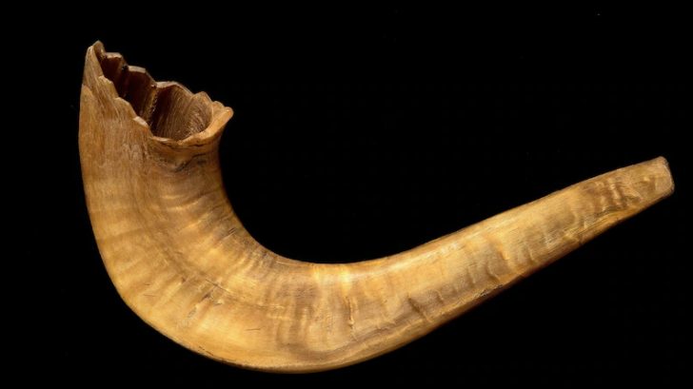
The shofar recently lent by Judith Tydor Schwartz to the Museum of Jewish Heritage – A Living Memorial to the Holocaust in New York for the exhibition “Auschwitz. Not long ago. Not far away.” (Museum of Jewish Heritage NYC / John Halpern)
In synagogues around the country, Jews will gather on Monday for Rosh Hashanah, the New Year holiday. A central element during prayer services will be a few simple notes blown on a shofar, a musical instrument fashioned from a ram’s horn and used since ancient times.

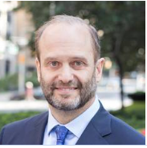
Rabbi Chaim Steinmetz

This year, a shofar will be blown in our synagogue, Kehilath Jeshurun in New York, that bears a remarkable story of faith and hope. The shofar was recently lent to the Museum of Jewish Heritage — A Living Memorial to the Holocaust in New York to be put on display in “Auschwitz. Not long ago. Not far away,” a traveling exhibition of more than 700 objects and 400 photographs that tell the story of the complex of German death camps and forced-labor camps in World War II.
The shofar’s lender is Judith Tydor Schwartz, the director of Holocaust research at Bar-Ilan University in Israel. She is the daughter of a Holocaust survivor, Chaskel Tydor, who died in 1993 at age 89. The shofar, Schwartz says, had been used clandestinely at Auschwitz. It had remained with the family since the war and is being displayed publicly for the first time.
How the shofar — a curved, tapering horn about 10 inches long — got to Auschwitz is unknown. Holocaust historians think it was probably smuggled there in the spring of 1944 by Jews deported from Hungary. Possession of a religious object was punishable by death.
Schwartz says her father, tasked with organizing work details of fellow prisoners, helped a group of pious men to celebrate Rosh Hashanah that year. Tydor dispatched them to perform less-supervised tasks that day, enabling them to say the High Holiday prayers undetected. When they returned, they told Tydor that the covert service had even included the blowing of a shofar that had been kept hidden for that purpose.

The Rag-Wrapped Shofar
In January 1945, as the Russian army began to advance, the German guards moved Auschwitz inmates westward from occupied Poland into Germany. Tens of thousands were sent on these death marches, including Tydor. At the beginning of the journey, according to Schwartz’s account, a prisoner handed the rag-wrapped shofar to Tydor, saying he was certain to die on the trip but wanted the world to know that the shofar had been blown at Auschwitz.
One should never underestimate the power of faith and hope. Some public intellectuals dismiss religion as an emotional crutch, a coping mechanism for the weak-minded. Certain in their disbelief in God, they can only explain the staying power of religion as the result of a mental flaw. These theories are not new; they have their roots in the views of Freud, Marx and Nietzsche, who saw religion as an infantile diversion. The shofar from Auschwitz asserts otherwise.
It would have taken enormous courage for those men to risk their lives by blowing the shofar. Such an act of faith during the war was hardly an isolated episode. A multitude of testimonies describe Jews making steep sacrifices to retain their religious and spiritual identity in the concentration camps. They fashioned makeshift ritual items. They recited prayers in private, using secreted pages from prayer books and smuggled prayer shawls.

Inspired by Their Faith
The men and women who performed these acts of religious observance were living examples of the biblical words “even though I walk through the valley of the shadow of death, I fear no evil for you are with me.” They were inspired by their faith to exceptional bravery, to spiritually resist the Nazis.
The Auschwitz shofar is not just a historical artifact; it carries a profound message, even for times of peace and prosperity. People have painful struggles even in the best of times, and many must make the difficult journey through the valley of the shadow of death. Sometimes, hopelessness seems to be the only rational response. But those prisoners with the shofar at Auschwitz had a different perspective. They showed that at the doorstep of hell, hope and faith are possible.
On Rosh Hashanah, our congregation will hear the story of this small group of spiritual heroes, whose example offers a timeless lesson of belief and determination — a particularly inspiring way to greet a new year.

Reprinted from an op-ed piece posted on September 29, 2022. Chaim Steinmetz is the senior rabbi of Congregation Kehilath Jeshurun in New York.

A Shanah Tovah Greeting from last year

Simonim for the Festive Meal of Rosh Hashanah
Simple Actions

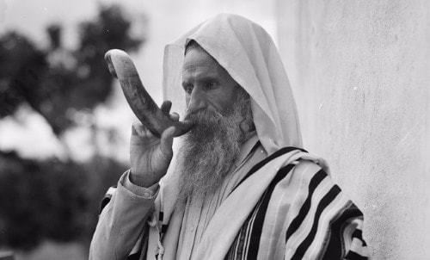
A Yemenite Jew blows shofar (circa 1930s).

What do I have to do to make a difference in the world? We often think that the ones who make the greatest impact are the people that make the cover of Time magazine or win the Nobel Prize.
But the truth is that the simple actions of so-called simple people are what really make a difference. When we do things right, it becomes contagious. When we listen to the sound of the shofar, we shake.
It sounds like the primal cry of a child for his mother. It is the inner cry of every soul, recognizing that as great as we are, we remain impossibly distant from our Father in Heaven; no matter how wise or discerning we become, the soul is, after all, far away from home. The shofar’s cry reminds us of our purpose, our priorities, and empowers us to stay focused on the meaning of life and avoid getting caught up in the pitfalls and challenges of material life.
And the really amazing thing is that we are able to achieve this clarity through the simple act of hearing the cry of the shofar. Nothing fancy – just a simple horn with a simple sound from the head of a simple beast. Just as the world is transformed by every simple thing we do. I can’t recall ever getting inspired to emulate the work of the nuclear physicist who won the Nobel Prize, but I can remember dozens of times that the simple actions of simple people have motivated me to emulate them and become better.
***
Rosh Hashana marks the anniversary of the creation of Adam and Eve in the Garden of Eden. It’s our collective birthday. Therefore, in addition to being the Jewish New Year, a time for moral introspection and positive resolutions, it is also a time to appreciate the tremendous capacities and gifts that we possess as human beings, and as Jews.
At the same time, with the recognition that we have these talents and powers that can change the world comes the responsibility to do just that – to utilize all of the power within us and utilize their fullest potential to improve our lives, the lives of those around us and of all humanity. All of this is expressed in the fact that Rosh Hashana, which is known as the Day of Judgment for all of Creation, is not observed on the day when the world was created, but on the day that humanity was created.
This impresses upon us the fact that the destiny of all life on earth depends on humanity. Furthermore, even one person can make a monumental difference, as expressed in the fact that all of humanity descends from one man and one woman. The first action undertaken by Adam upon his creation was to look around at all the amazing fauna, the diversity of animals and life, the heavens and the earth, and to declare his awe of G-d’s creation, and to inspire the rest of creation to follow suit.
In a sense, this is exactly what we do on Rosh Hashana: We look around (and within) and we declare that though we may get a little sidetracked here and there, G-d is the real reality in our lives, and we resolve to make this recognition a practical part of our daily lives.

Reprinted from the Parshas Nitzavim 5782 edition of L’Chaim, a publication of the Lubavitch Youth Organization in Brooklyn.

The Shofar Blasts
By A. Ben-Ami

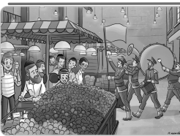
Illutrated by M. Weinreb

The Horowitz boys hurried along with Totty as they went around Passaic, NJ dropping off stacks of Toras Avigdor at the various distribution points.
“Wait,” said Sholom, after leaving a pile of booklets at Bagel Munch. “Bagel Munch is our last stop. Why do we still have more booklets left in the bag?”
“Well there is a new location that we are delivering to starting this week,” Totty replied, as the family got back into the car.
“Oh look!” exclaimed Mordechai, as they pulled into a large parking lot. “It’s the grand opening of the new Aisle One kosher supermarket!”
“I heard it’s supposed to be an amazing event!” Sholom said. “There’s going to be free cotton candy, a marching band, and the mayor, Lector Hora, is going to be there!”
“Oh wow, is this where we’re dropping off the Toras Avigdor booklets?” asked Yisroel Meir, excitedly.
“It sure is,” Totty said, smiling again. “Come, let’s go inside.”
Inside the store, the Horowitz boys stared in astonishment at the size of the new supermarket. There were so many aisles - it looked like you could park a jumbo jet inside the store!

He Has His Own Kashrus Agency
“Look, Totty!” Yisroel Meir said. “There’s the Spira family from down the block! And there’s Rabbi Isaacson,” said Yisroel Meir. “Did you know he has his own kashrus agency? Maybe he’s here to make sure everything is kosher!”
Just then everybody was startled by a sudden loud trumpet sound. “Toooooo, Tooooooo, Tooooo,” and the band began to play with a loud clash of cymbals, accompanied by trombones and french horns.
“What’s happening?” asked Mordechai. “Oh, it must be an important guest has arrived. I’m not sure who it is but let’s try to get close to the stage and see who it is.” Sure enough, as soon as the trumpets quieted down, the popular mayor of Passaic, Lector Hora, ascended the stage and began to speak about how important the new store is for the city and how he hoped it would solve all of the city’s parking and plumbing problems.
Once everything had died down and the Horowitzes finished their Shabbos shopping, Totty handed the stack of Toras Avigdor booklets to the manager and they headed back to their car.
“Wow, that was so fun, Totty!” said Sholom. “Thanks for taking us to the grand opening!”

“I Thought it was a Smoke Alarm or Something”
“Yeah,” added Mordechai. “But Totty, when they blew the trumpets I thought it was a smoke alarm or something. How did you know that the trumpet meant that someone important is arriving?
“Well, it’s just like when we blow the Shofar,” said Totty as he and the boys loaded the grocery bags into the back of the car. The boys looked at each other, confused. They had been hearing the Shofar in shul the entire Elul and didn’t remember anything happening after the Shofar was blown.
“But nothing happens when we blow the Shofar,” said Yisroel Meir, confused. “The baal tokeia just blows and then we continue davening.”
“Nothing happens?” said Totty as everyone got into the car and buckled up. “The biggest thing happens! Hashem arrives! That’s what I learned from this morning's Toras Avigdor email. When somebody asked Rav Miller why we blow shofar on Rosh Hashana, he explained that in the olden days when a King was arriving in a city for a visit, they blew trumpets. It was a way of showing special honor to the King, to greet him with blasts of a shofar. Totty continued as he started driving.
“The same way that people use the trumpets of a marching band to signal that someone important is coming, we also do the same with the trumpet of Klal Yisroel.”
“The Shofar is the trumpet of Klal Yisroel?” asked Mordechai. Yes, the Shofar says ‘He is here! The King has arrived!’ The boys thought about this for a few minutes.
“I never realized that,” said Sholom. “I thought it’s just a Mitzvah that we do.”
“Every Mitzvah is more than ‘just a Mitzvah’, Sholom,” said Totty. “Hashem gives us Mitzvos because they are supposed to make us think. Each time we do a Mitzvah, we should be thinking about Hakadosh Boruch Hu - and doing so brings us closer to him. And when it comes to tekias shofar, one of the most important thoughts is that Hashem is arriving to judge us.
As they drove home, Sholom and Yisroel Meir discussed how they would be trying to use what Totty just told them to enhance their davening this Rosh Hashana. But Mordechai was just sitting quietly, frowning at the booklet in his lap.
“Is everything okay, Mordechai?” asked Totty.
“Yeah, it’s just that the story in this week’s Toras Avigdor Junior is all about us and what just happened. How did they know?”

Reprinted from this week’s edition of Toras Avigdor Junior adapted from the teachings of Rabbi Avigdor Miller, zt”l.

Holiday Memories
By Rabbi Berel Wein

For me, the holiday season that we are now in, is a time of mixed emotions. They engender within all of us the understanding that circumstances change in the progress of life and its events. Therefore, I am taking the liberty of sharing some of my holiday memories with you. Nostalgia can be very alluring, but there is also always a modicum of hard-headed realism that memories of the past always evoke.
In short, memories are always bittersweet, because the past can never be brought to life again. In fact, an overabundance of effort on memory can be counterproductive to accomplishment and emotional balance in circumstances of personal and national events.

Our memories oftentimes play tricks on the mind. This is especially true during this season of the high holy days when so much emotion is present within our families and our communities.

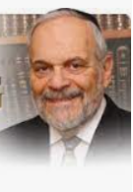
Rabbi Berel Wein

We all feel that it is not only those who are present that are commemorating the holiday, but also those who are no longer with us, who are also present in a very tangible manner in all our holiday activities and prayers. The events of past holidays weigh heavily upon the convictions of the commemoration and the celebration of the high holy days of this year as well.

When I was a child growing up in Chicago, I remember vividly that on the afternoon of the first day of Rosh Hashanah, my mother and I sat on the front porch of my grandfather's house. In front of me passed a sea of people walking to the Douglas Park lagoon in the neighboring park for the Tashlich service. Newspapers in Chicago estimated the crowds to number at least 40,000. Every Jew in the Lawndale area where I lived walked to the lagoon. There was no vehicular traffic on the street. People walked on the sidewalk, in the middle of the street, in the middle of the grassy Boulevard and all over the byway that led to the park.

It was the religious and social event of the year that united the entire Jewish community living in the area’s densely packed apartments and row houses. This was an opportunity to show their solidarity and connection the Jewish tradition and values. That memory, which was fixed into my young mind, has never departed or been diminished since. I don't know if there is any other such mass demonstration anywhere in the Jewish world outside of Israel today. It certainly is no longer present in Chicago.

I often think about the descendants of those 40,000 Jews that at one time walked to that lagoon to observe the custom of Tashlich. Tragically, I am certain that many of their descendants may no longer be Jewish, and, certainly, are not aware of this tradition. The ravages of assimilation over my lifetime destroyed much of the Jewish community, not only of Chicago, but also of America in general. But my memory of that Tashlich event still nurtures me until this very day.

The synagogues in Chicago engaged the services of the most famous legendary cantors of the time. Many of the synagogues had very large buildings that could accommodate thousands of worshipers at one time. The synagogue where my father was the rabbi, was perhaps the smallest of the large synagogues in the area. It contained about 1500 seats in the main sanctuary and in the women's gallery. Onthe high holy days, every seat was occupied and at certain points during the services, people stood in the aisles.

It was a generation mainly of Eastern European Jews, who brought that fervor and flavor to the high holy day services. When everyone stood to recite the prayer, there was a roar of sound and a sea of tears that I have never again seen equaled at any prayer service. These were plain simple Jews, struggling to make a living in an alien environment, and attempting, at the same time, to hold onto their faith. Most failed to accomplish this, but there was a minority who succeeded, and we are grateful to that minority for the restoration of traditional Jewish life throughout the world.

Reprinted from the Parshat VaYelech 5781 email of Rabbi David Bibi’s Shabbat Shalom from Cyberspace.

